Title
First-name SURNAME¹; Second AUTHOR^{2,*}

- First Author’s Affiliation, City, Postcode, Country
- Second Author’s Affiliation, City, Postcode, Country

Key words: Manuscript, Preparation, Typeset

Abstract: Reviews normally should have 150–300 words in the abstract, be continuous (not structured) and without reference numbers. Reviews may have different sections and sub-headings according to the subject matter. The main headings of the review should be summarized as a numbered ‘Contents’ section immediately following the ‘Abstract’.

Introduction
Authors are encouraged to use the Microsoft Word template when preparing the final version of their manuscripts. In introduction, authors should provide a context or background for the study (that is, the nature of the problem and its significance). State the specific purpose or research objective of, or hypothesis tested by, the study or observation. Cite only directly pertinent references, and do not include data or conclusions from the work being reported.
Main Text
The text should be written in clear, concise English, and it should be easily understandable to a broad readership. Sentences should not begin with abbreviations or numerals. Main headings should be Introduction, Material and Methods, Results (or Systematic Description), Discussion and Acknowledgements (if necessary) and they should be centered and in capital letters, while just one level of subsidiary headings should be on the left, in italics). Do not number headings. Combining Results and Discussion is not allowed.
Linnean scientific names should be in italics, while higher than generic taxa should not. The generic name of drugs, as well as all other common names, should be written in lower case. Gene designations should be in lower case and in italics, while protein designations should be in regular capital letters.
Text Layout
Acceptable paper size is US A4 (21 cm × 29.7 cm). All margins – top (1.34 cm), bottom (0.49 cm), left (1.52 cm),

*Address correspondence to: Author’sName, author@institute.xxx
Received: xx Month Year; Accepted: xx Month Year
and right (1.31 cm). Acceptable font is Minion Pro, 10 pt., except for writing special symbols and mathematical equations. Use 0.7 cm intend on the first line of second paragraph.
Materials and Methods
Any commercialized kits, reagents, instruments, software, antibodies, etc. used in the research, shall be provided with their full name, along with the information of the Manufacturers/suppliers/software details (Name, City, Province/State, Country).
Accession numbers of RNA, DNA and protein sequences used in the manuscript should be provided.
Abbreviations
Abbreviations should be defined in parentheses the first time they appear in the abstract, main text, and in figure or table caption and used consistently thereafter. Accepted abbreviations for statistical parameters are: P, n, SD, SEM, df, ns, ANOVA, t. Naming of chemicals should follow that given in Chemical Abstracts Service.
Units
Units of measurement should be used concisely according to the International System of Units (SI). All units should be converted to SI units whenever possible.
Statistical Analysis
Appropriate statistical treatment of the data is essential. When statistical analysis is performed, the name of the statistical test used, the number for each analysis, the comparisons of interest, the alpha level and the actual p-value for each test should be provided.

TABLE 1

Table caption

1 | 2 | 3
4 | 5 | 6
11 | 12 | 13

Figures and Tables
Figures and tables should be inserted in the text of the manuscript.
Figures
F Authors should include all figures and tables in the PDF file of the manuscript. Figures should be centered, and should have a figure caption placed underneath. The size of the figures is measured in centimeters and inches. Please prepare your figures at a size within 17 cm (6.70 in) in width and 20 cm (7.87 in) in height. Figures should be placed in the text immediately after the point where they are referenced. In the main text, where referencing the figures, use Fig. followed by a space and the figure number, e.g., Fig. 1. The digital format JPEG, PNG, TIFF are acceptable, with >300 dpi resolution.
Images of cells and western blots should be large enough to see the relevant features. In addition, uncropped, untouched, full original images of western blots should be uploaded with the other figure files.
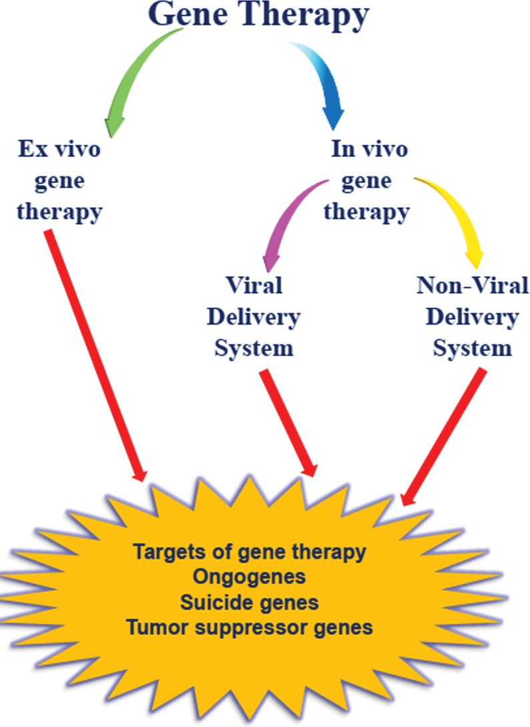
FIGURE 1. An overview of gene therapies in melanoma.
Tables
Tables should be typed on separate sheets, and they should be numbered in Arabic numerals, and cited as such in the Text. Units and the statistics employed should be clearly explained either in the table’s body or in the footnotes to the table. Tables should be editable by the editorial office and not appear in a picture format. Captions should be centered in the format “TABLE 1: The text caption …”. For one example, see Table 1.
Copyright of Figures
If a figure or table has been published previously (even if you were the author of the manuscript), copyright permission for reuse of the figure or table will often be required. The acknowledgement and written permission from the copyright holder will be required where necessary.
Figure Legends
They should be self-explanatory without reference to the text. Statistical evaluations should indicate the test used. Micrographs magnification should be indicated by scale bars on them, and the size of the scale bar should be indicated in the legend, not on the micrograph. When the same magnification is used for several panels of the same figure, a single scale bar should be used.
Figure Labels
The size of labels should be no smaller than 8-point and no larger than the font size of the main text. Figure labels must be sized in proportion to the image, sharp, and legible. Labels must be saved using standard fonts (Arial, Helvetica or Symbol font) and should be of the same font and size in all figures in one paper. All labels should be in black, and should not be overlapped, faded, broken or distorted. The first letter of each phrase, NOT each word, must be capitalized.
Citations
For citations of references, e.g., (Aitken, 1989) or (Moos and Hackstadt, 1987); (Aitken, 1989; Moos and Hackstadt, 1987); If there are more than two authors, you can write the first author' last names following the mark ‘et al.,’. (Hoover et al., 2002). Please read the following requirements and examples carefully.
The author-year format of the citation must be used for the references. The author-year format of the citation must be used for the references. For example, (Atluri, 1986). If the cited reference has two authors, please see the example, (Atluri and Han, 2000). If the cited reference has more than three authors, please cite all first three authors’ last names, and followed by “et al.,”. For example, (Atluri, Nakagaki, Han et al., 2000). When you cite more than one reference, please cite each reference and separate them by a semicolon, see (Atluri, 1998; Atluri and Nakagaki, 1986; Atluri et al., 2000). If the sentence starts with a referenced author's name, please cite right after the author’s name. For example, “Martinez et al. (2014) determined the presence of ...”. No citation to the page number should be used.
All references should be listed at the end of the paper. The names of the authors, with the last name(s) first, followed by the year in which the paper is published. Journal and book titles should be in italic. A full name of journal cited in reference should be used followed the volume and page number. References at the end should be listed in alphabetical order.
Author Contribution
This statement should make clear the contribution of all authors. An author name can appear multiple times, and each author name must appear at least once. It can be described in the following manner:

The authors confirm contribution to the paper as follows: study conception and design: X. Author, Y. Author; data collection: Y. Author; analysis and interpretation of results: X. Author, Y. Author. Z. Author; draft manuscript preparation: Y. Author. Z. Author. All authors reviewed the results and approved the final version of the manuscript.

For single authors, it can be described in the following manner:
The author confirms sole responsibility for the following: study conception and design, data collection, analysis and interpretation of results, and manuscript preparation.
Acknowledgment
All contributors who do not meet the criteria for authorship should be listed in this section.
Availability of Data and Materials
This statement—which is not required for review articles—should make clear how readers can access the data used in the study and explain why any unavailable data cannot be released.

Ethics Approval
Should the experiments involve human subjects, animals, or plants, please highlight the detailed ethical licensing information in this section including name of the ethics committee, ethical approval code, and date of approval, etc.
Funding Statement
Authors must disclose all sources of funding for the research in the Funding Statement of the article. The statement should be specifying the role of each in the design of the study, the collection, analysis, and interpretation of data, and the composition of the manuscript. Specifically, the full name of each source of funding should be provided accompanied by any associated grant numbers in square brackets, URLs to sponsors’ websites. If the study has no funding support, please include “The author(s) received no specific funding for this study.” in the funding statement. Funding sources should not be written in the Acknowledgments or anywhere else in the manuscript file.
Conflicts of Interest
Authors must declare all potential conflicts of interest; if they have none to declare, they should state plainly, “The authors declare that they have no conflicts of interest to report regarding the present study.”
References
Antoniades C, Bakogiannis C, Tousoulis D, Antonopoulos AS, Stefanadis C (2009). The CD40/CD40 ligand system: linking inﬂammation with atherothrombosis. Journal of the American College of Cardiology 54: 669–677. DOI 10.1016/ j.jacc.2009.03.076.
Arnold ES, Fischbeck KH (2018). Spinal muscular atrophy. Handbook of Clinical Neurology, 148: 591–601.
Baker CR, Hanson-Smith V, Johnson AD (2013). Following gene duplication, paralog interference constrains transcriptional circuit evolution. Science 342: 104–108.
Calucho M, Bernal S, Alías L, March F, Venceslá A, RodríguezÁlvarez FJ, Aller E, Fernández RM, Borrego S, Millán JM, Hernández-Chico C, Cuscó I, Fuentes-Prior P, Tizzano EF (2018). Correlation between SMA type and SMN2 copy number revisited: An analysis of 625 unrelated Spanish patients and a compilation of 2834 reported cases. Neuromuscular Disorders 28: 208–215.

