***Type: XXXX***

**Your Paper Title Goes Here and Capitalize Each Letter**

First-name Surname1 and Second Author2,*

1First author’s affiliation, Address, City, Postcode, Country

2Second author’s affiliation, Address, City, Postcode, Country

*Corresponding Author: Author’s Name. Email: author@institute.xxx

Received: XXXX; Accepted: XXXX.

**Abstract:** Please type your abstract here. Original research, systematic reviews, and meta analyses require structured abstracts. The abstract should provide the context or background for the study and should state the study’s purpose, basic procedures (selection of study participants, settings, measurements, analytical methods), main findings (giving specific effect sizes and their statistical and clinical significance, if possible), and principal conclusions. Clinical trial abstracts should include items that the CONSORT group has identified as essential.

**Keywords:** Manuscript; preparation; typeset; format

**1 Introduction**

Authors are encouraged to use the Microsoft Word template when preparing the final version of their manuscripts. In introduction, authors should provide a context or background for the study (that is, the nature of the problem and its significance). State the specific purpose or research objective of, or hypothesis tested by, the study or observation. Cite only directly pertinent references, and do not include data or conclusions from the work being reported.

**2 Main Text** **Structure**

The text should be written in clear, concise English, and it should be easily understandable to a broad readership. Sentences should not begin with abbreviations or numerals. Main headings should be Introduction, Material and Methods, Results (or Systematic Description), Discussion and Acknowledgements (if necessary) and they should be centered and in capital letters, while just one level of subsidiary headings should be on the left, in italics). Do not number headings. Combining Results and Discussion is not allowed.

***2.1 Text Layout***

Acceptable paper size is US Letter (8.5” × 11” or 21.59 cm × 27.94 cm). All margins - top, bottom, left, and right-are set to 1” (2.54 cm). The paper must be single column, single spaced, except for the headings as outlined below. Acceptable font is Times New Roman, 11 pt., except for writing special symbols and mathematical equations. Use 2-character intend on the first line of each new paragraph.

***2.2 Headings***

Level one headings for sections should be in bold, 11 pt., and be flushed to the left. Level one heading should be numbered using Arabic numbers, such as 1, 2, ….

Level two headings for subsections should be in bold-italic, 11 pt., and be flushed to the left. Level two headings should be numbered after the level one heading. For example, the second level two heading under the third level one heading should be numbered as 3.2.

Level three headings should be in italic, 11 pt., and be flushed to the left. Similarly, the level three headings should be numbered after the level two headings, such as 3.2.1, 3.2.2, etc.

***2.3 Materials and Methods***

Any commercialized kits, reagents, instruments, software, antibodies, etc. used in the research, shall be provided with their full name, along with the information of the Manufacturers/suppliers/software details (Name, City, Province/State, Country). Accession numbers of RNA, DNA and protein sequences used in the manuscript should be provided.

***2.4 Statistical Analysis***

Appropriate statistical treatment of the data is essential. When statistical analysis is performed, the name of the statistical test used, the number for each analysis, the comparisons of interest, the alpha level and the actual *p*-value for each test should be provided.

***2.5 Results***

Present your results in logical sequence in the text, tables, and figures, giving the main or most important findings first. Do not repeat all the data in the tables or figures in the text; emphasize or summarize only the most important observations. Provide data on all primary and secondary outcomes identified in the Methods section.

***2.6 Discussion***

It is useful to begin the discussion by briefly summarizing the main findings, and explore possible mechanisms or explanations for these findings. Emphasize the new and important aspects of your study and put your findings in the context of the totality of the relevant evidence. State the limitations of your study, and explore the implications of your findings for future research and for clinical practice or policy. Discuss the influence or association of variables, such as sex and/or gender, on your findings, where appropriate, and the limitations of the data. Do not repeat in detail data or other information given in other parts of the manuscript, such as in the Introduction or the Results section

***2.7 Conclusion***

Conclusions can be linked with discussion or separately stated. Conclusions should state the goals of the study but avoid unqualified statements and conclusions not adequately supported by the data.

**3 Abbreviations and Units**

***3.1 Abbreviations***

Abbreviations should be defined in parentheses the first time they appear in the abstract, main text, and in figure or table caption and used consistently thereafter. Accepted abbreviations for statistical parameters are: P, n, SD, SEM, df, ns, ANOVA, t. Naming of chemicals should follow that given in ***Chemical Abstracts Service.***

***3.2 Units***

Units of measurement should be used concisely according to the International System of Units (SI). All units should be converted to SI units whenever possible.

**4 Figures and Tables**

Figures and tables should be placed in the text soon after the point where they are referenced.

***4.1 Figures***

Where reference the figures, use Fig. followed by a space and the figure number, e.g., Fig. 1.

Figures should have relevant legends but should not contain the same information which is already described in the main text. Figures (diagrams and photographs) should also be numbered consecutively using Arabic numbers. They should be placed in the text soon after the point where they are referenced. Figures must be submitted in digital format, with resolution higher than 300 dpi.

*4.1.1 Figure Format*

Figures should be centered, and should have a figure caption placed underneath. Captions should be centered in the column, in the format “**Figure 1:** The text caption …”, where the number of the figure follows the key word Figure, and the text caption comes right after that.

The size of the figure is measured in centimeters and inches. Please prepare your figures at the size within 17 cm (6.70 in) in width and 20 cm (7.87 in) in height. Figures should be in the original scale, with no stretch or distortion.

*4.1.2 Figure Labels and Captions*

Figure labels must be sized in proportion to the image, sharp, and legible. Label size should be no smaller than 8-point and no larger than the font size of the main text. Labels must be saved using standard fonts (Arial, Helvetica or Symbol font) and should be consistent for all the figures. All labels should be in black, and should not be overlapped, faded, broken or distorted. A space must be inserted before measurement units. The first letter of each phrase, NOT each word, must be capitalized. If the figure is combined, each part of the segments should be appropriately labeled and should be described in the captions and legends of the figure.

One-line Caption should be centered in the column, in the format of “**Figure 1:** The text caption …” That is, the number of the figure follows the keyword **Figure**, and next to it, the text caption. For one example, see Fig. 1 below.

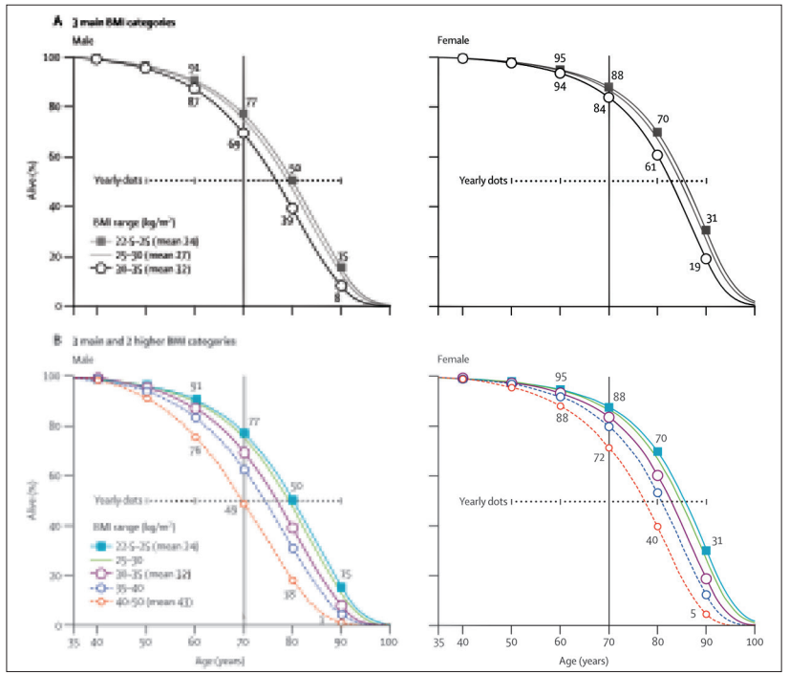

Figure 1: Some functions of 

***4.2 Tables***

Where reference the Tables, please use abbreviation “Tab.”. followed by the number, e.g., Tab. 1.

Tables should also be numbered consecutively using Arabic numbers. They should be placed in the text soon after the point where they are referenced. Tables should be centered and should have a table caption placed above. Captions should be centered in the format “**Table 1:** The text caption …”. For one example, seeTab. 1.

Table 1: Table caption

|  |  |  |
| --- | --- | --- |
| 1 | 2 | 3 |
| 11 | 12 | 13 |
| 21 | 22 | 23 |

# 5 Citations

For citations of references, please use square brackets and consecutive numbers, [1] [2,3], [4–6].

e.g., Percutaneous ASD closure has gained wide acceptance over surgical option for both patients and parents [1]. As the procedure is minimally invasive with less hospital stay, it has been increasingly introduced over the last three decades [2,3]. Starting from simple defects with adequate rims up to defects with more complex anatomy and relatively deficient rims [4-6].

**Acknowledgement:** Acknowledgements and Reference heading should be left justified, bold, with the first letter capitalized but have no numbers. Text below continues as normal.

**Funding Statement:** Authors should describe sources of funding that have supported the work, including specific grant numbers, initials of authors who received the grant, and the URLs to sponsors’ websites. If there is no funding support, please write “The author(s) received no specific funding for this study.”

**Conflicts of Interest:** Authors ***must*** declare all conflict of interests. If there is no conflict of interests, it should also be declared as in ex. “The authors declare that they have no conflicts of interest to report regarding the present study.”

**Data sharing:** Data sharing statement must contain whether individual deidentified participant data (including data dictionaries) will be shared; what data in particular will be shared; whether additional, related documents will be available (e.g., study protocol, statistical analysis plan, etc.); when the data will become available and for how long; by what access criteria data will be shared (including with whom, for what types of analyses, and by what mechanism).

# References [Please make sure the page number of the reference is complete, the author's name is complete, and the format is correct, especially the comma and full stop between full last name(s), and first name(s) in initial(s)]

References should be organized in order of citation in the main. All references should be in font size 10 and listed at the end of the paper. The names of the authors should be the full last name(s), and first name(s) in initial(s), followed by the year in which the paper is published. *A full name of journal* cited in reference should be in italic font and followed by the Volume number. Volume number is followed by the issue number in parentheses, both Vol number and issue number should be in italic font. Use a comma before the page number.

Regarding the format of DOI, please don’t use the URL. (SEE BELOW)

Based on our particular style, the first five authors will be listed as they appear. When more than five authors are listed, keep the first five authors and followed by et al. (see reference 6.)

The following are examples of order and style, which should be strictly adhered to:

1. Atluri, S. N.(2004). *A four-node hybrid assumed-strain finite element for laminated composite plates*. USA: Tech Science Press.
2. Lara, D. A., Lopez, K. N. (2014). Public health research in congenital heart disease. *Congenital Heart Disease, 9(6),* 549–558. DOI: 10.1111/chd.12235
3. Moodie D. (2016). The Journal Congenital Heart Disease--2016. *Congenital Heart Disease, 11(1),* 5–6. DOI 10.1111/chd.12342
4. Atluri, S. N.(2004).The meshless method (MLPG) for domain & BIEdiscretization*.* http://www.techscience.com/books/mlpg_atluri.html.
5. Darius, H. (2014). *Savant syndrome-theories and empirical findings* *(Ph.D. Thesis)*. University of Turku, Finland.
6. Philip, R., Nathaniel Johnson, J., Naik, ssR., Kimura, D., Boston, U. et al. (2019). Effect of patent ductus arteriosus on pulmonary vascular disease. *Congenital Heart Disease, 14(1),* 37–41. DOI 10.1111/chd.12702

# Appendix A. Example of appendix

Authors that need to include an appendix should place it after the References section. Multiple appendices are allowed and they should be labeled in the order in which they appear in the text. Each of the appendices shall have its heading that follows the style detailed in Section 2.2. Appendices shall be labeled as Appendix A, Appendix B, Appendix C, etc.