DOI: 10.32604/chd.202x.0xxxxx

ARTICLE…
Title

First-name Surname¹ and Second Author^{2,*}
¹First Author’s Affiliation, City, Postcode, Country
²Second Author’s Affiliation, City, Postcode, Country
*Corresponding Author: Author’s Name. Email: author@institute.xxx
(Note: The number of Correspondence Authors is limited to 2. The provided correspondence emails must be valid and should accurately reflect the names or affiliations of the correspondence authors. Please note that QQ emails are not considered acceptable.)
Received: XXXX Accepted: XXXX
ABSTRACT
For Original Articles, please provide a structured abstract of no more than 250 words, divided into four sections: Background (or Objectives), Methods, Results, Conclusions. A merged Methods and Results subheading is also permitted if this permits more economical expression. Abbreviations that appear only once in the abstract should be defined in full. If abbreviations appear more than once, the full definitions should be provided first before they can be used elsewhere.
KEYWORDS
Manuscript; preparation; typeset; format

Nomenclature
Term 1 Interpretation 1
Term 2 Interpretation 2
e.g.
$∅$ Porosity
s Skin factor
1 Introduction
Authors are encouraged to use the Microsoft Word template when preparing the final version of their manuscripts. In introduction, authors should provide a context or background for the research (that is, the nature of the problem and its significance). Briefly summarizes why this study is unique and may include medical literature references. Cite only directly pertinent references, and do not include data or conclusions from the work being reported.
It is essential to articulate the study's goals and objectives within the broader subject area. Provide a background to the research by referencing prior work, and introduce the research question that will guide the investigation. This comprehensive approach ensures clarity in defining the study's purpose, situating it within existing knowledge, and framing the inquiry for a focused exploration.
2 Methods (Methods and Materials/Methods and Patients)
The methods section is tasked with offering comprehensive details on the materials and methodologies employed, enabling others to replicate the study. Adhering to established reporting guidelines, this section should also incorporate a concise discussion on any measures taken to control bias or mitigate unwanted sources of variability. Additionally, it is imperative to address any limitations associated with the datasets, contributing to a transparent and thorough presentation of the research methodology.
To enhance the article’s readability, we recommend incorporating subheadings within this section. Utilizing subheadings such as "Study Design," "Data Collection," and "Data Analysis" can effectively organize and present information in a structured manner. This approach not only facilitates a clearer understanding of the research process but also assists readers in navigating through the content with ease. Subheadings serve as valuable signposts, guiding the audience through distinct aspects of the study methodology, ultimately contributing to a more accessible and comprehensible
3 Results
This section is dedicated to presenting the comprehensive results of the study. It is important to provide a thorough account of the findings according to the methods, ensuring a complete and detailed representation of the results. From key observations to statistical analyses, every aspect of the study's results should be meticulously presented in this section. Transparency and clarity in conveying the results contribute to the overall credibility of the research, allowing readers to grasp the significance and implications of the study's result.
4 Figures and Tables
Figures and tables should be inserted in the text of the manuscript.
4.1 Figures
Figures should have relevant legends but should not contain the same information which is already described in the main text. Figures (diagrams and photographs) should also be numbered consecutively using Arabic numbers. They should be placed in the text soon after the point where they are referenced. Figures must be submitted in digital format, with resolution higher than 300 dpi.
For example: Fig. 1
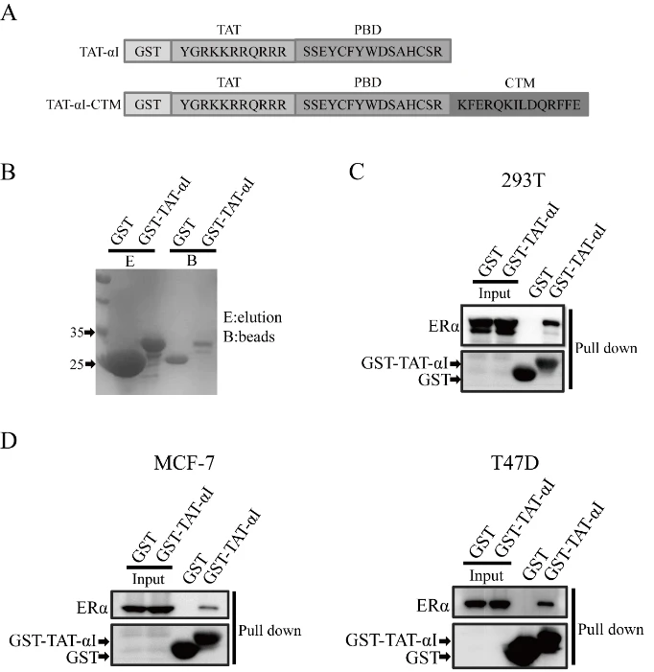

Figure 1: The binding of peptide αI to ERα. (A) Design TAT-αI-CTM and TAT-αI peptides. (B) Production of GST and GST-TAT-αI using an E. coli expression system. Coomassie blue staining after SDS-PAGE assessed their purity. (C) Pull-down of TAT-αI and ERα. HEK 293T cells were transiently transfected with plasmids pEGFP-N2-ERα. 48 h after transfection, cell lysates were subjected to GST pull down, and the pull-down fractions were immunoblotted analyzed. (D) Pull-down of TAT-αI and ERα in ERα-positive breast cancer cell lines, MCF-7 and T47D.
4.2 Tables
Tables should also be numbered consecutively using Arabic numbers. They should be placed in the text soon after the point where they are referenced. Tables should be centered and should have a table caption placed above. Captions should be centered in the format “Table 1: The text caption …”. For one example, see Table 1. If the caption has more than one line, the text should be justify aligned on both ends.
Table 1: Table caption
1 | 2 | 3
11 | 12 | 13
21 | 22 | 23

5 Discussion
In this section, it is crucial to comprehensively discuss the study results within the context of existing references. Address the study's limitations and delve into the implications of the findings. Highlight both the strengths and weaknesses of the research, fostering a nuanced understanding. Additionally, suggest directions for future research, providing guidance for upcoming investigations based on the study outcomes. By engaging in a thoughtful discussion that covers these elements, this section contributes to a holistic interpretation of the study's significance, offering valuable insights and paving the way for future research endeavors.
6 Conclusions
This section provides a brief overview of the key points discussed in the article. The author may offer suggestions and recommendations for clinicians or researchers. In journals where a separate conclusion section is not required, it can be incorporated as the concluding paragraph within the Discussion section.
Acknowledgement: Acknowledgement and reference heading should be left justified, bold, with the first letter capitalized but have no numbers. Text below continues as normal.
Funding Statement: Authors should describe sources of funding that have supported the work, including specific grant numbers, initials of authors who received the grant, and the URLs to sponsors’ websites. If there is no funding support, please write “The author(s) received no specific funding for this study”.
Author Contributions: The Author Contributions statement is mandatory. It should represent all the authors and is to be included upon submission. It can be up to several sentences long and should briefly describe the tasks of individual authors. All listed authors should have substantially contributed to the manuscript and have approved the final submitted version, which should include a description of each author’s specific work and contribution.
We suggest the following format for the contribution statement:
The authors confirm contribution to the paper as follows: study conception and design: X. Author, Y. Author; data collection: Y. Author; analysis and interpretation of results: X. Author, Y. Author. Z. Author; draft manuscript preparation: Y. Author. Z. Author. All authors reviewed the results and approved the final version of the manuscript.
Availability of Data and Materials: This statement should make clear how readers can access the data used in the study and explain why any unavailable data cannot be released.
Informed Consent (Provide if requested.): Authors should obtain written consent from the patient and provide it upon request by the editorial office. If the patient is a minor, it is necessary to obtain parental consent. In situations where adults are unable to provide consent for investigation or treatment, the consent of the closest family members is required.
Conflicts of Interest: Authors must declare all conflicts of interest. If there is no conflicts of interest, it should also be declared as in ex, please write “The authors declare that they have no conflicts of interest to report regarding the present study”.
Supplementary Materials: Supplementary Materials should be uploaded separately on submission. The supplementary files will also be available to the referees as part of the peer-review process. Any file format is acceptable; however, we recommend that common, non-proprietary formats are used where possible.
Supplementary materials should be clean, without tracked changes, highlights, comments or line numbers.
Supplementary figures must be clear and readable, and we recommend a minimum resolution of 300 dpi, figure legends must be clear and accurate.
Supplementary materials must be mentioned in the main text. The citation format of Supplementary Figure, Table, Equation, etc., should start with a prefix S (i.e., Fig. S1, Eq. (S2), Table S1, etc.).
References: Vancouver Referencing Style
Reference of a book:
Author AA. Title. Publisher Location: Publisher; Year.
- Murray PR, Rosenthal KS, Kobayashi GS, Pfaller MA. Medical microbiology. 4th ed. St. Louis: Mosby; 2002.
Reference of a book (works in non-English languages):
Author AA. English Title. Publisher Location: Publisher; Year (In original language).
- Zhou CH, Luo JC. Geo–Computing of high resolution satellite remote sensing images. China: Science Press; 2009. p. 1–3 (In Chinese).
Reference of a book chapter:
Author AA. Chapter title. In: Authors. Title. Publisher Location: Publisher; Year. Page.
- Meltzer PS, Kallioniemi A, Trent JM. Chromosome alterations in human solid tumors. In: Vogelstein B, Kinzler KW, editors. The genetic basis of human cancer. New York: McGraw-Hill; 2002. p. 93–113.
Reference of a journal article:
Author AA. Title. Journal Name(abbreviation). Year Published; volume number(issue number):page number.
In the event that there are more than six authors, please list the first six authors, and the rest can be represented by et al (See example 2).
- Halpern SD, Ubel PA, Caplan AL. Solid-organ transplantation in HIV-infected patients. N Engl J Med. 2002;347(4):284–7.
- Hallal AH, Amortegui JD, Jeroukhimov IM, Casillas J, Schulman CI, Manning RJ, et al. Magnetic resonance cholangiopancreatography accurately detects common bile duct stones in resolving gallstone pancreatitis. J Am Coll Surg. 2005;200(6):869–75.
- Kanneganti P, Harris JD, Brophy RH, Carey JL, Lattermann C, Flanigan DC. The effect of smoking on ligament and cartilage surgery in the knee: a systematic review. Am J Sports Med. 2012;40(12):2872–8. Available from: http://ajs.sagepub.com/content/40/12/2872 doi: 10.1177/03635465124582236.

Reference of an online source:
Author AA. Title. URL. [Year Published].
- Atluri SN. The meshless method (MLPG) for domain & BIE discretizations. Available from: http://www.techscience.com/info/mlpg_atluri. [Accessed 2004].
Reference of a thesis:
Author AA. Title (Level). Institution Name: Location; Year Published.
- Darius H. Savant syndrome-theories and empirical findings (Ph.D. Thesis). University of Turku: Finland; 2014.
Reference of conference:
Author AA. Title. In: Conference Name, Year Published; Location.
- Howe B, Lee P, Grechkin M, Yang ST, West JD. Deep mapping of the visual literature. In: Proceedings of the 26th International Conference on World Wide Web Companion; 2017 Apr 3-7; Perth, Australia. Geneva; International World Wide Web Conferences Steering Committee; 2017 [cited 2021 Aug 12]; p. 1273–7. Available from: ACM Digital Library doi:10.1145/3041021.3053065
Reference of government reports:
Author AA, Author BB. Title of report. Place of publication: Publisher; Date of publication. Total number of pages. Report No.:
- Rowe IL, Carson NE. Medical manpower in Victoria. East Bentleigh (AU): Monash University, Department of Community Practice; 1981. 35 p. Report No.: 4.
Appendix A. Example of appendix
Authors that need to include an appendix should place it after the References section. Multiple appendices are allowed and they should be labeled in the order in which they appear in the text. Each of the appendices shall have its heading that follows the style detailed in Section 2.2. Appendices shall be labeled as Appendix A, Appendix B, Appendix C, etc. The references in the appendix should be attached at the end of the appendix and renumbered from 1. The format should be consistent with the reference in the main text.

