Running Title:
Manuscript Type: Article, Review, Opinion, etc.
Title
First-name SURNAME¹, Second AUTHOR^{2,*}

- Department, University, City, Postcode, Country
- Department, University, City, Postcode, Country

Key words: Manuscript, Preparation, Typeset

Abstract: If your manuscript is a research article, please make your abstract presented in a structural manner. A structured abstract is an abstract with distinct, labeled sections (e.g., Introduction or Objectives or Background, Methods, Results, Conclusion) for rapid comprehension. Manuscripts of the 'Review' type do not need to have their abstract structured in this manner.

Introduction
Authors are encouraged to use the Microsoft Word template when preparing the final version of their manuscripts. In introduction, authors should provide a context or background for the study (that is, the nature of the problem and its significance). State the specific purpose or research objective of, or hypothesis tested by, the study or observation. Cite only directly pertinent references, and do not include data or conclusions from the work being reported.
Main Text
The text should be written in clear, concise English, and it should be easily understandable to a broad readership. Sentences should not begin with abbreviations or numerals. Main headings should be Introduction, Material and Methods, Results (or Systematic Description), Discussion and Acknowledgements (if necessary) and they should be centered and in capital letters, while just one level of subsidiary headings should be on the left, in italics). Do not number headings. Combining Results and Discussion is not allowed.
Linnean scientific names should be in italics, while higher than generic taxa should not. The generic name of drugs, as well as all other common names, should be written in lower case. Gene designations should be in lower case and in italics, while protein designations should be in regular capital letters. "In vitro" and "in vivo", whether in the text or on the figure, should be italic. All the p in p value, whether in the text or on the figure, should be lowercase and italic.

*Address correspondence to: Author’s Name, author@institute.xxx (The number of Correspondence Authors is limited to 2. The provided correspondence emails must be valid and should accurately reflect the names or affiliations of the correspondence authors. Please note that QQ emails are not considered acceptable.)
Received: xx Month Year; Accepted: xx Month Year
Text Layout
Acceptable paper size is US A4 (21 cm × 29.7 cm). All margins – top (1.34 cm), bottom (0.49 cm), left (1.52 cm), and right (1.31 cm). Acceptable font is Minion Pro, 10 pt., except for writing special symbols and mathematical equations. Use 0.7 cm intend on the first line of second paragraph.
Materials and Methods
Any commercialized kits, reagents, instruments, software, antibodies, etc. used in the research, shall be provided with their full name, along with the information of the Manufacturers/suppliers/software details (Company Name, City, Province/State, Country).
Accession numbers of RNA, DNA and protein sequences used in the manuscript should be provided.
For experiments reporting results on animal or human subject research, an ethics approval statement should be included in this section.
Abbreviations
Abbreviations should be defined in parentheses the first time they appear in the abstract, main text, and in figure or table caption and used consistently thereafter. Accepted abbreviations for statistical parameters are: P, n, SD, SEM, df, ns, ANOVA, t. Naming of chemicals should follow that given in Chemical Abstracts Service (https://www.cas.org/).
Units
Units of measurement should be used concisely according to the International System of Units (SI). All units should be converted to SI units whenever possible.
Statistical Analysis
Appropriate statistical treatment of the data is essential. When statistical analysis is performed, the name of the statistical test used, the number for each analysis, the comparisons of interest, the alpha level and the actual p-value for each test should be provided.

TABLE 1

Table caption

1 | 2 | 3
4 | 5 | 6
11 | 12 | 13

Figures and Tables
All the figures and tables should be inserted in the text of the manuscript.
Figures should be centered and should have a figure caption placed underneath. The size of the figures is measured in centimeters and inches. Please prepare your figures at a size within 17 cm (6.70 in) in width and 20 cm (7.87 in) in height. Figures should be placed in the text immediately after the point where they are referenced. In the main text, where referencing the figures, use Fig. followed by a space and the figure number, e.g., Fig. 1. The digital format JPEG, PNG, TIFF are acceptable, with >300 dpi resolution.
Images of cells and western blots should be large enough to see the relevant features. In addition, uncropped, untouched, full original images of western blots should be uploaded with the other figure files.
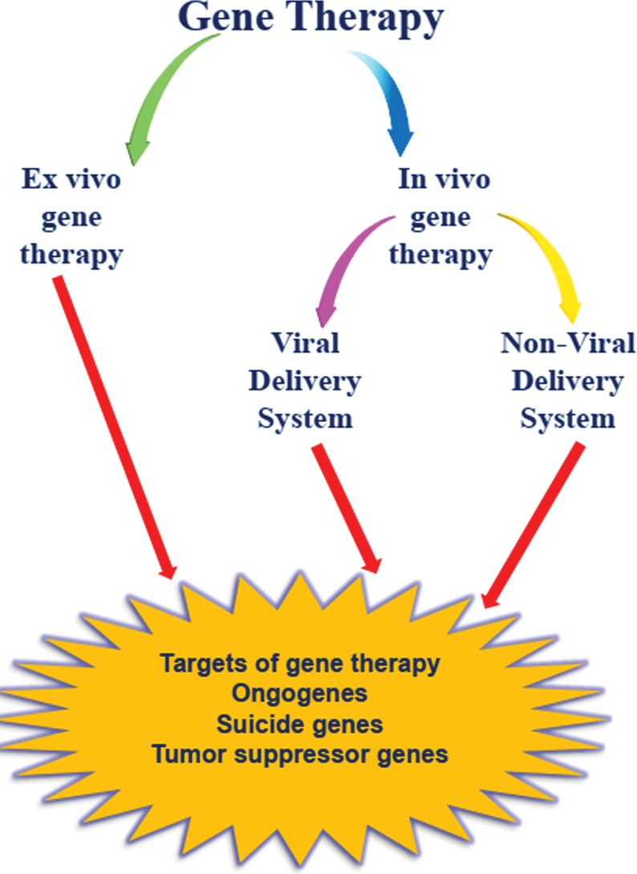
FIGURE 1. An overview of gene therapies in melanoma.
Tables should be typed on separate sheets, and they should be numbered in Arabic numerals, and cited as such in the Text. Units and the statistics employed should be clearly explained either in the table’s body or in the footnotes to the table. Tables should be editable by the editorial office and not appear in a picture format. Captions should be centered in the format “TABLE 1: The text caption …”. For one example, see Table 1.

Figure copyright guidelines
All figures, tables, and images will be published under a Creative Commons CC-BY license, and permission must be obtained for the use of copyrighted material from other sources. If a figure or table has been published previously (even if you were the author of the manuscript), copyright permission for reuse of the figure or table will often be required. The acknowledgement and written permission from the copyright holder will be required where necessary. It is the responsibility of the authors to acquire the licenses, follow any citation instructions requested by third-party rights holders, and cover any supplementary charges.
Figure citation guidelines
Ensure all figures are numbered in the order in which they appear.
To clarify, figure discussions are organized in the following manner: E.g. Fig. 1a, Fig. 1b, Fig. 1c, Fig. 1d, followed by Fig. 2a, Fig. 2b, Fig. 2c, Fig. 2d, and so forth. It is erroneous to include figure discussions as demonstrated in such instances: Fig. 1a, Fig. 1b, Fig. 3a, Fig. 2a, Fig. 1c, Fig. 1d, Fig. 2b, Fig. 2c, Fig. 4a, Fig. 3c, Fig. 3d, and so on.
In summary, the inclusion of new figure discussions within the context of another figure's discussion is not permissible.
Figure legend guidelines
Provide a short title (in the legend, not on the figure itself) and an explanation in brief but sufficient detail to make the figure intelligible without reference to the text. Statistical evaluations should indicate the test used.
Scale bar guidelines
A scale bar, rather than magnification, must be provided for any micrographs. The scale bar should be explicitly and prominently displayed on each figure; one cannot simply add a line on the figures without any scale bar description or simply add a description of the scale in the figure legend without a scale bar in the figure. This practice is mandatory for all micrographs and petri dish diagrams.
Figure label guidelines
The size of labels should be no smaller than 8-point and no larger than the font size of the main text. Figure labels must be sized in proportion to the image, sharp, and legible. Labels must be saved using standard fonts (Arial, Helvetica or Symbol font) and should be of the same font and size in all figures in one paper. All labels should be in black, and should not be overlapped, faded, broken or distorted. The first letter of each phrase, NOT each word, must be capitalized.

In-Text Citations
Manuscripts must be prepared according to the Vancouver reference style. The in-text citation is placed immediately after the text which refers to the source being cited:
Using square brackets: as one author has put it “the darkest days were still ahead” [1].
All references should be listed at the end of the manuscript. When the number of authors is six or fewer, please include all their names. If there are more than six authors, list the first six authors' names and use et al. to denote the remaining authors.
The journal title should be an abbreviation. After the journal abbreviation, include the publication year, volume number (issue number), and page number. For example: N Engl J Med. 2002;347(4):284-7
Acknowledgment (all types of manuscripts should have this section.)
All contributors who do not meet the criteria for authorship should be listed in this section.
In the event that the authors have no acknowledgments to make, kindly include the term "None" in this section to indicate its absence.
Funding Statement (all types of manuscripts should have this section.)
Authors must disclose all sources of funding for the research in the Funding Statement of the article. Specifically, the full name of each source of funding should be provided accompanied by any associated grant numbers in square brackets, URLs to sponsors’ websites. If the study has no funding support, please include “The author(s) received no specific funding for this study.” in the funding statement. Funding sources should not be written in the Acknowledgments or anywhere else in the manuscript file.
Author Contributions (all types of manuscripts should have this section.)
The Author Contributions statement is mandatory. It should represent all the authors and is to be included upon submission. It can be up to several sentences long and should briefly describe the tasks of individual authors. All listed authors should have substantially contributed to the manuscript and have approved the final submitted version, which should include a description of each author’s specific work and contribution.
We suggest the following format for the contribution statement:
The authors confirm contribution to the paper as follows: study conception and design: X. Author, Y. Author; data collection: Y. Author; analysis and interpretation of results: X. Author, Y. Author. Z. Author; draft manuscript preparation: Y. Author. Z. Author. All authors reviewed the results and approved the final version of the manuscript.
Availability of Data and Materials (all types of manuscripts should have this section)
This statement should make clear how readers can access the data used in the study and explain why any unavailable data cannot be released.
You can take one of the following forms:
a. The datasets generated during and/or analyzed during the current study are available in the [NAME] repository, [PERSISTENT WEB LINK TO DATASETS].
b. The datasets generated during and/or analyzed during the current study are available from the corresponding author on reasonable request.
c. All data generated or analyzed during this study are included in this published article (and its supplementary information files).
d. The datasets generated during and/or analyzed during the current study are not publicly available due to [REASON(S) WHY DATA ARE NOT PUBLIC] but are available from the corresponding author on reasonable request.
e. Data sharing not applicable to this article as no datasets were generated or analyzed during the current study.
f. The data that support the findings of this study are available from [THIRD PARTY NAME] but restrictions apply to the availability of these data, which were used under license for the current study, and so are not publicly available. Data are however available from the authors upon reasonable request and with permission of [THIRD PARTY NAME].
Ethics Approval (all types of manuscripts should have this section.)
In this statement, please make the ethical statement as detailed as possible. Ethical licensing information must include name of the ethics committee, ethical approval code, and date of approval, etc.
Manuscripts reporting studies involving animals, human participants, human data or human must:①include a statement on ethics approval and consent (even where the need for approval was waived); ②include the name of the ethics committee that approved the study；③the reference number about this ethics approval and consent.
Studies involving animals must include a statement on ethics approval and for experimental studies involving client-owned animals, authors must also include a statement on informed consent from the client or owner.
If your manuscript does not report on or involve the use of any animal or human data or tissue, please state “Not applicable” in this section.
Conflicts of Interest (all types of manuscripts should have this section.)
Authors must declare all potential conflicts of interest; if they have none to declare, they should state plainly, “The authors declare that they have no conflicts of interest to report regarding the present study.”
Supplementary Materials
Supplementary Materials should be uploaded separately on submission. The supplementary files will also be available to the referees as part of the peer-review process. Any file format is acceptable; however, we recommend that common, non-proprietary formats are used where possible.
Supplementary materials should be clean, without tracked changes, highlights, comments or line numbers.
Supplementary figures must be clear and readable, and we recommend a minimum resolution of 300 dpi, figure legends must be clear and accurate.
Supplementary materials must be mentioned in the main text. The citation format of Supplementary Figure, Table, Equation, etc., should start with a prefix S (i.e., Fig. S1, Eq. (S2), Table S1, etc.).
References: Vancouver Referencing Style
References Style file for EndNote: Vancouver.
Reference of a book:
Author AA. Title. Publisher Location: Publisher; Year.
- Murray PR, Rosenthal KS, Kobayashi GS, Pfaller MA. Medical microbiology. 4th ed. St. Louis: Mosby; 2002.
Reference of a book (works in non-English languages):
Author AA. English Title. Publisher Location: Publisher; Year (In original language).
- Zhou CH, Luo JC. Geo. Computing of high resolution satellite remote sensing images. China: Science Press; 2009. p. 1–3 (In Chinese).
Reference of a book chapter:
Author AA. Chapter title. In: Authors. Title. Publisher Location: Publisher; Year. Page.
- Meltzer PS, Kallioniemi A, Trent JM. Chromosome alterations in human solid tumors. In: Vogelstein B, Kinzler KW, editors. The genetic basis of human cancer. New York: McGraw-Hill; 2002. p. 93–113.
Reference of a journal article:
Author AA. Title. Journal Name(abbreviation). Year Published; volume number(issue number):page number.
In the event that there are more than six authors, please list the first six authors, and the rest can be represented by et al (See example 2).
- Halpern SD, Ubel PA, Caplan AL. Solid-organ transplantation in HIV-infected patients. N Engl J Med. 2002;347(4):284–7.
- Hallal AH, Amortegui JD, Jeroukhimov IM, Casillas J, Schulman CI, Manning RJ, et al. Magnetic resonance cholangiopancreatography accurately detects common bile duct stones in resolving gallstone pancreatitis. J Am Coll Surg. 2005;200(6):869–75.
- Kanneganti P, Harris JD, Brophy RH, Carey JL, Lattermann C, Flanigan DC. The effect of smoking on ligament and cartilage surgery in the knee: a systematic review. Am J Sports Med. 2012;40(12):2872–8. Available from: http://ajs.sagepub.com/content/40/12/2872 doi: 10.1177/03635465124582236.

Reference of an online source:
Author AA. Title. URL. [Year Published].
- Atluri SN. The meshless method (MLPG) for domain & BIE discretizations. Available from: http://www.techscience.com/info/mlpg_atluri. [Accessed 2004].
Reference of a thesis:
Author AA. Title (Level). Institution Name: Location; Year Published.
- Darius H. Savant syndrome-theories and empirical findings (Ph.D. Thesis). University of Turku: Finland; 2014.
Reference of conference:
Author AA. Title. In: Conference Name, Year Published; Location.
- Howe B, Lee P, Grechkin M, Yang ST, West JD. Deep mapping of the visual literature. In: Proceedings of the 26th International Conference on World Wide Web Companion; 2017 Apr 3-7; Perth, Australia. Geneva; International World Wide Web Conferences Steering Committee; 2017 [cited 2021 Aug 12]; p. 1273–7. Available from: ACM Digital Library doi:10.1145/3041021.3053065
Reference of government reports:
Author AA, Author BB. Title of report. Place of publication: Publisher; Date of publication. Total number of pages. Report No.:
- Rowe IL, Carson NE. Medical manpower in Victoria. East Bentleigh (AU): Monash University, Department of Community Practice; 1981. 35 p. Report No.: 4.

