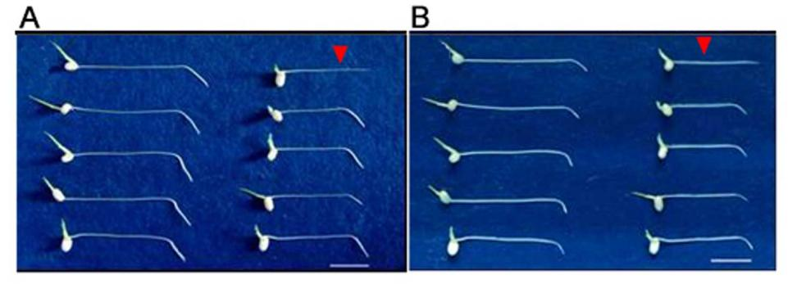
Supplementary Figure 1: Gravitational response of the wild-type plant ZH-11 and the lrl3 T2 generation. (A) and (B) are 12h and 24h primary root horizontal phenotypes of two-day-old seedlings, respectively. On the left are the wild-type plant ZH-11, and on the right are lrl3 T2 generation (arrows indicate lrl3 mutant, and others are wild-type individuals).

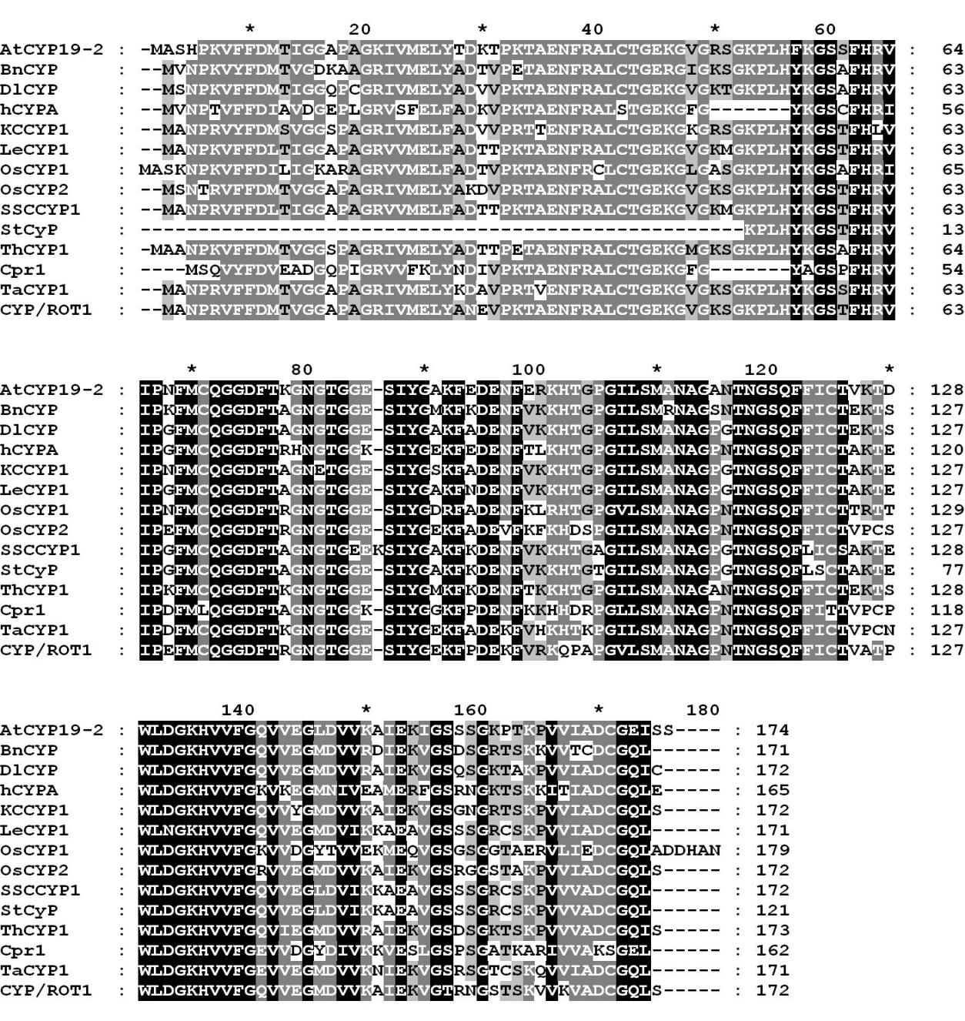
Supplementary Figure 2: Protein alignment between rice and other organisms with cyclophilin_ABH_like domain. AtCYP19-2, A. thaliana（gi：98960923）；BnCYP, Brassica napus (gi: 1345921); DlCYP, Digitalis lanata (gi: 1563719); hCYPA, Human sapiens (gi: 13543666); KCCYP1, Kandelia candel (gi: 37722431); LeCYP1, Lycopersicon esculentum (gi: 170439); OsCYP1, Oryza sativa (gi: 600764); OsCYP2, Oryza sativa (gi: 600768); Cpr1, S. cerevisiae (gi: 6320359); SSCCYP1, Solanum commersonii (gi: 1928938); StCyP, Solanum tuberosum (gi: 62529356); ThCYP1, Thellungiella halophila(gi：38708271); TaCYP1, Triticum aestivum (gi：13925734); CYP/ROT1, Zea mays (gi: 118104).

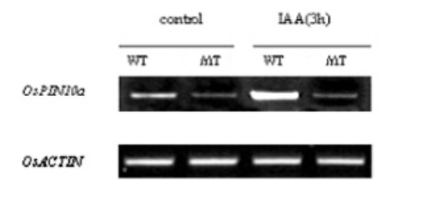

Supplementary Figure 3: Semi-quantitative RT-PCR of OsPIN10a in Kasalath and Oscyp2-2

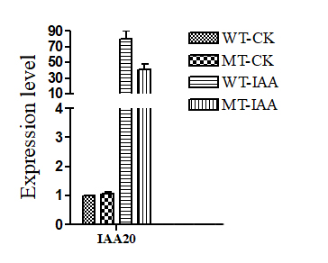
Supplementary Figure 4: Real-time quantitative RT-PCR expression in roots of Kasalath and Oscyp2-2.

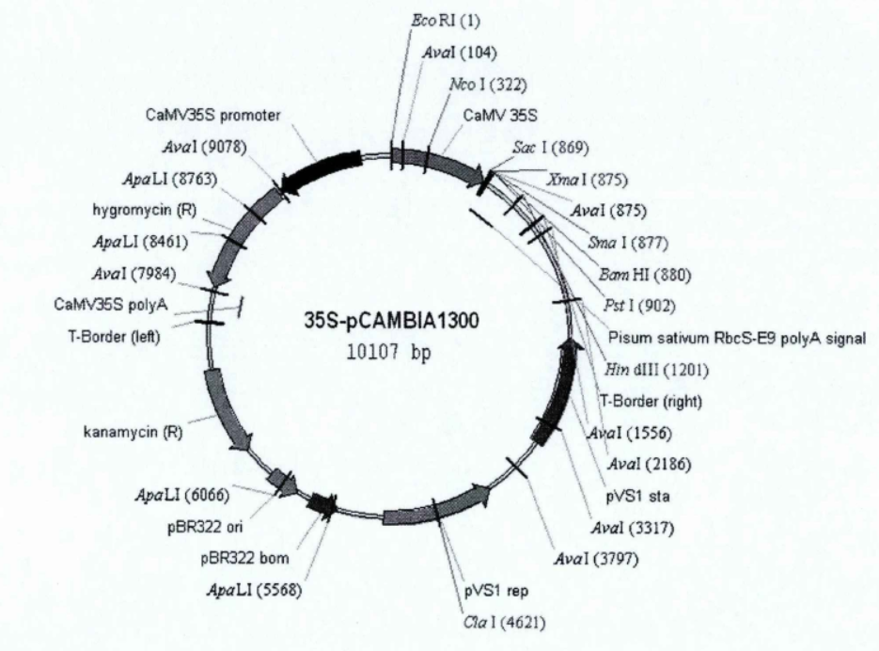
Supplementary Figure 5: The Vector of 35S-pCAMBIA1300

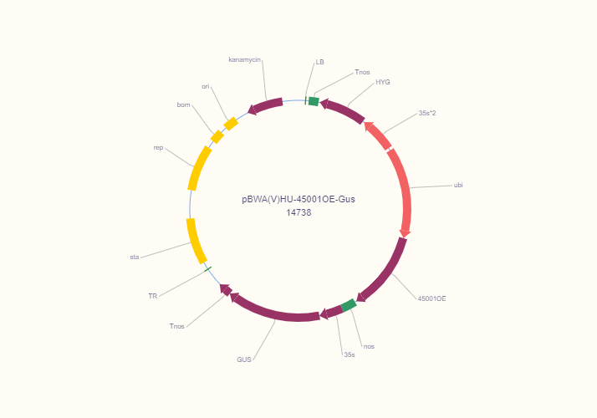
Supplementary Figure 6: The Vector of pBWA(V)HU-45001OE-Gus

Supplementary Table 1: Primers used in this study

Marker name | Marker type | Primer sequence(5'-3') | Restriction enzymes | Expected PCR lrl3 | product size(bp) Kasalath | Functiondescription
SIS2（M2） | STS | F:CTCTTGGGAGTCCTAACT  R:GCATGGTCCAAATGGTAT | no | 269 | 281 | gene mapping
RM12368 | SSR | F:GAGATAAGTGCCACGATTGATTGC  R:GGAGCCGTACGAGTAATCTCTGC | no | 152 | 162 | gene mapping
Note: The information of molecular markers used in this study is derived from the reported research (Kang and Zhang et al., 2013).

Marker name | Primer sequence(5'-3') | Expected PCR zh-11 | Expected PCR lrt2 | Expected PCR lrl3 | Expected PCR F₁ | Functiondescription
cyp2-lrt2 | F:ACGAGGGTGTTCTTCGACAT  R:GAAGGTGCTCCCCTTGTAGT | 171 | 121 | 112 | 112 and 121 | Genetic complementary verification

Marker name | Primer sequence(5'-3') | Product size(bp) | Functiondescription
OsACTIN | F:TCCATCTTGGCATCTCTCAGC  R:AGCCTTGGCAATCCACATCT | 60 | RT-qPCR
OsCDPK7 | F:ACACCGAGATTCGTGATCTTATG  R:GTTCCTCTCGCTCCAGTTTATT | 114 | RT-qPCR
OsCYP2 | F:GTGGTGGTGGTGTTAGTCTTT  R:GATCCAAGAACTCCGCCTAATC | 93 | RT-qPCR
OsTPS38 | F:CTATGCCTCTCCAGATGTGTTC  R:CTGAGATGGGCAGCATTGTA | 117 | RT-qPCR
OsPIN10a | F:CGGCTCTACCACAAGGGATTG  R:TCATAGTCCAAGAAGGATGTAGTACA | 143 | RT-PCR
OsIAA20 | F:CATCCTCGGCTCATACGC  R:ATCGTGCCCATCCTCTTG | 79 | RT-qPCR

